Pu’u Kukui Elementary School
6th Annual PTSA Spring Fling
April 18th, 2020 2-6pm
DONATION FORM
Gift Certificate: Please provide the gift certificate(s) with this form. If you do not have a gift certificate available, please provide us with a description of your donation on your letterhead.
Merchandise: A Silent Auction volunteer will contact you to make arrangements for delivery or pickup of the item.
Cash Donation: Monetary donation will be greatly received. Please make check payable to: Pu’u Kukui Elementary School PTSA, no later than April 7th, 2020.
Please return this form with your donation and any brochure or display materials to: Pu’u Kukui Elementary School PTSA Attn: Patty Herren -Spring Fling – Silent Auction 3700 Kehalani Mauka Parkway Wailuku, HI 96793 OR you may go to the school office and drop it off, for delivery to the PTSA folder OR Fax to: 808.727.3120
If you have any questions, please contact ust: puukukuiptsa@gmail.com or 808.357.5675 Please submit your donation with this form to us by April 7th.
** All donations are tax deductible. Federal ID#30-0805232**
Company Name: ___________________________________________________________________________
Address: ____________________________________________________________________________
Contact Person:______________________________________________________________ Phone:________________________________
Email:_______________________________________________________________________
Donation Item or Service Description:___________________________________________________________________ ____________________________________________________________________________
Retail Value:__________________________
Student Name(s) we can thank for getting this donation if applicable:____________________________
Please Check What Applies: ___Donation/ Monetary is Enclosed ___Please Call me for delivery/pickup arrangement

Mahalo for your Kokua!
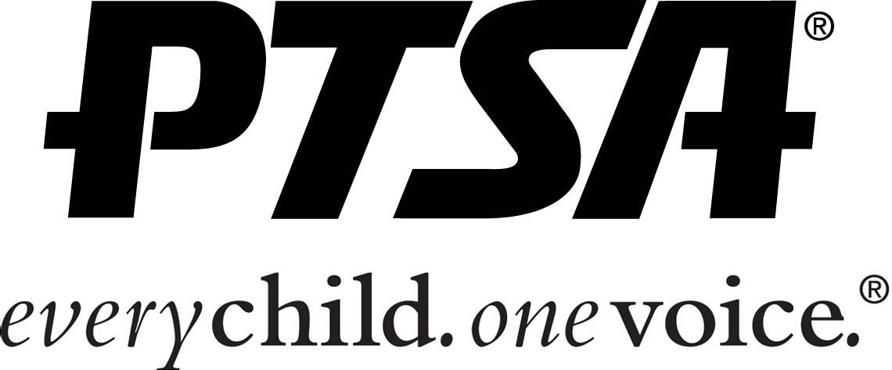
Puu Kukui PTSA
Office: (808) 727-3000 www.puukukuiptsa.com

